**DAILY ONLINE ACTIVITIES SUMMARY**

|  |  |  |  |  |  |  |  |  |
| --- | --- | --- | --- | --- | --- | --- | --- | --- |
| **Date:** | **29/06/2020** | | | | | **Name:** | **RITIKA R KULKARNI** | |
| **Sem& Sec** | **4​th​ SEM. & ‘B’ SEC.** | | | | | **USN:** | **4AL19CS403** | |
| **Online Test Summary** | | | | | | | | |
| **Subject** | | **- -** | | | | | | |
| **Max. Marks** | | **--** | | **Score** | | | **- -** | |
| **Certification Course Summary** | | | | | | | | |
| **Course** | **Introduction to Data Science** | | | | | | | |
| **Certificate Provider** | | | **Cognitive class** | | **Duration** | | | **5 Hrs.** |
| **Coding Challenges** | | | | | | | | |
| **Problem Statement:**   1. **Given a list of numbers, write a Python program to count Even and Odd numbers in a List.** | | | | | | | | |
| **Status: Executed** | | | | | | | | |
| **Uploaded the report in Github** | | | | | **Yes** | | | |
| **If yes Repository name** | | | | | <https://github.com/ritikakulkarni> | | | |
| **Uploaded the report in slack** | | | | | **Yes** | | | |

**Online Test Summary:**No internals conducted.

**Online Certification course Summary​:**I have taken my Online Certification Course in **Cognitive class** . Today I went through what are the applications and function of data science.

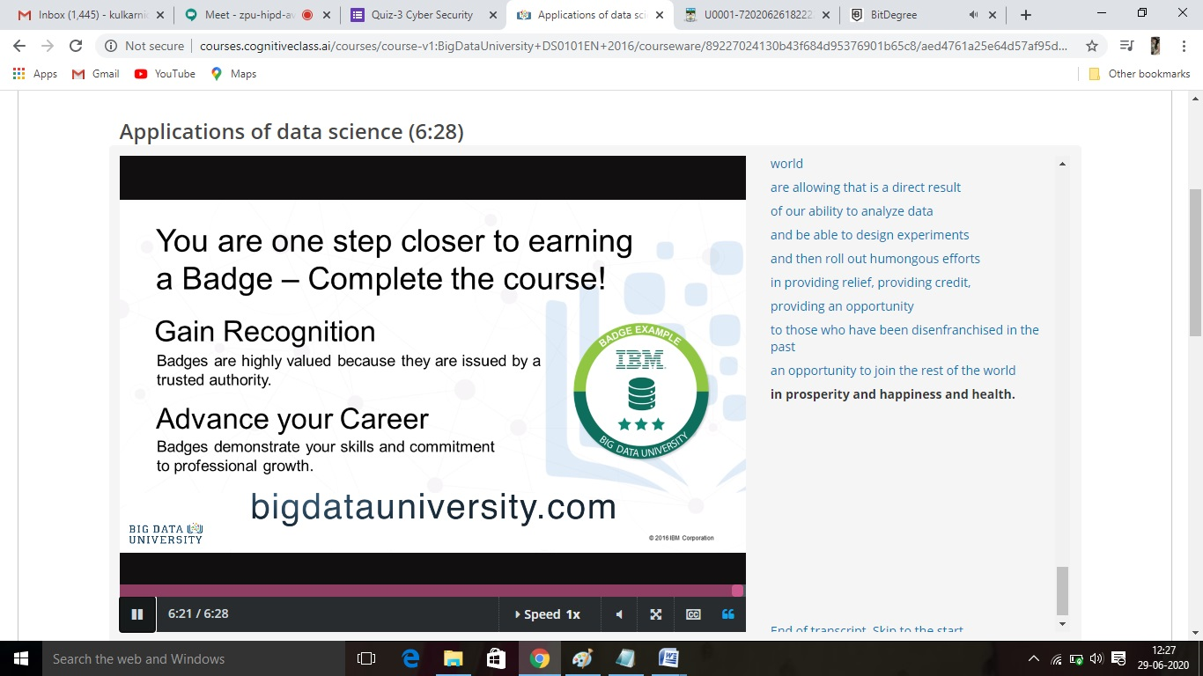

**Online Training**: Today I had attended the online training organized by CSE Dept AIET. The training was on Cyber Security done by Prof. Dr.Manjunatha Kotari HOD of CSE Dept. After the session the quiz was conducted. the snapshot that shown in below quiz attempted and the marks obtained.

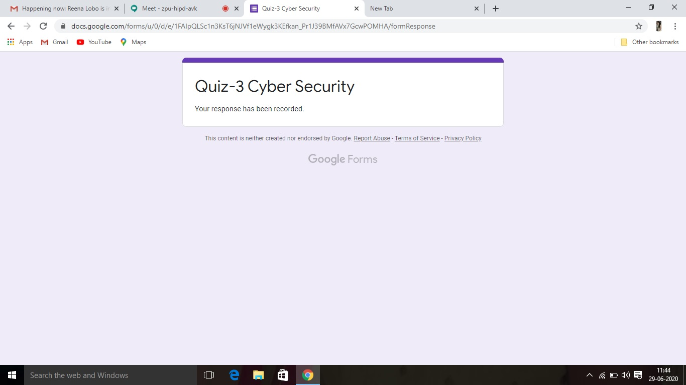

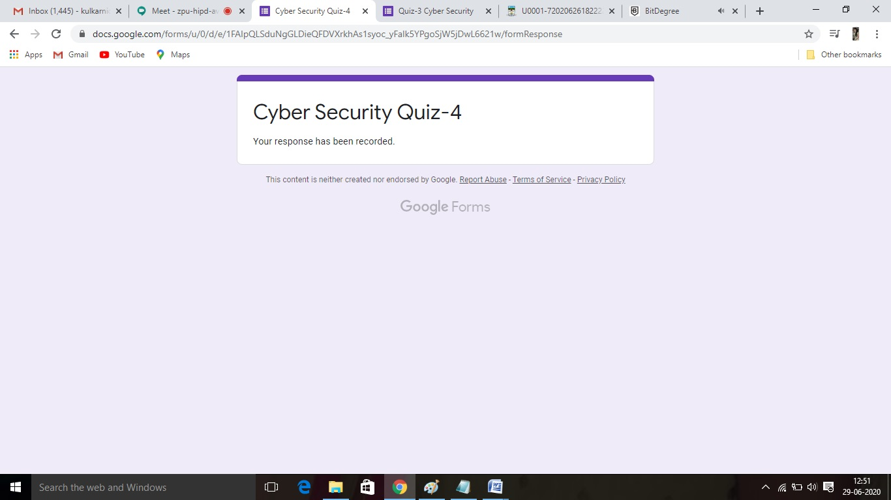

**Online Coding Summary​:Today I received one python program from Prof. Vasudev CSE Dept.. I have written one program and uploaded it to my Github repository. This is my repository snapshot. I have uploaded the frequency program.**

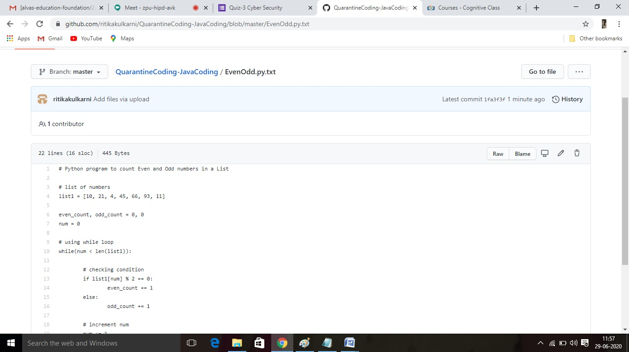

Thank you